OCR application
Quick user guide

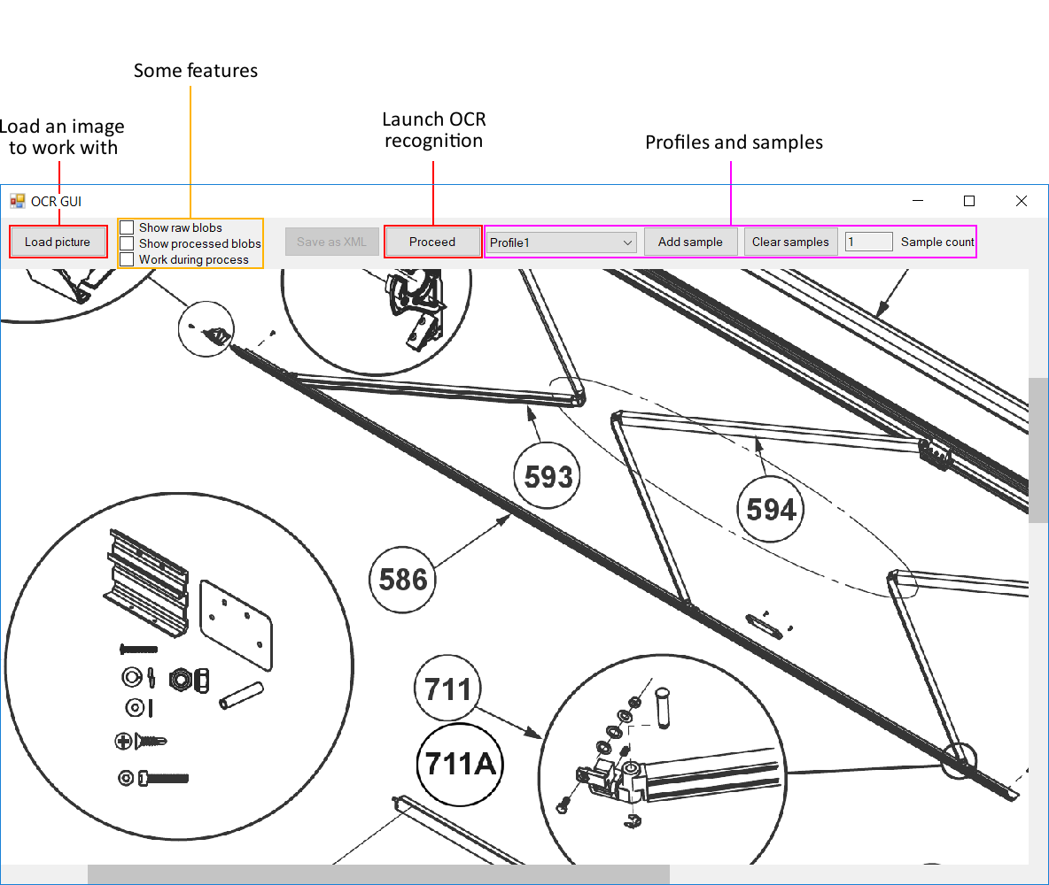
- Overview

- Profiles and samples
The goal of the application is to find the regions of interest (the hotspots) before applying the Tesseract OCR recognition. These regions are found using a profile that contains samples.
Each sample describes the properties (size, ratio, …) that can be used to find the associated hotspot collection. Some images only need one sample (all the hotspots are the same) whereas some other images require more than one (there are several hotspot collections with different properties).
With the checkboxes Show raw blobs and Show processed blobs, you can visualize all the regions of interest and the ones that have been selected with the samples :
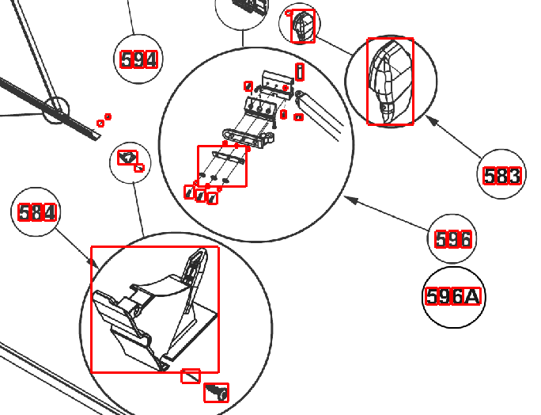

Raw blobs
The very first step of the algorithm
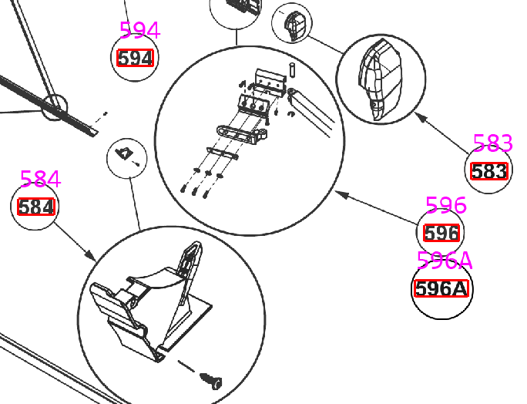
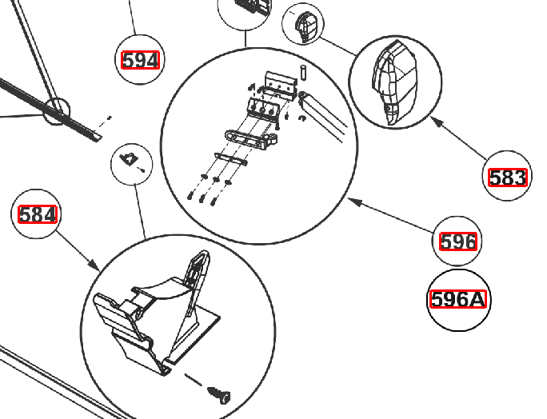
Final hotspots
The recognized hotspots
Processed blobs
The hotspots selected with the samples
Profile config file
You can describe profiles and samples using an XML config file. You need to name it ocr_profile.config and place it in C:\ProgramData\Signifikant\Assert\ so that the application can use it (each profile defined can then be selected though the application). The file is reloaded each time an image is loaded in the application.
The file consists of sample and profile declarations :
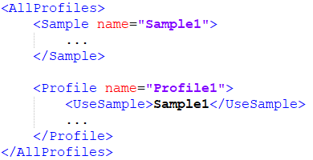

You can also declare samples directly in a profile (you don’t have to use the tag UseSample) :
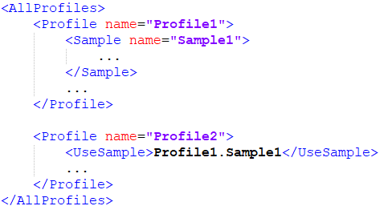

Profiles and samples can also inherit from other profiles and samples :
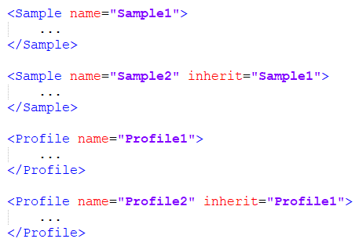

The XML fields for a profile are :
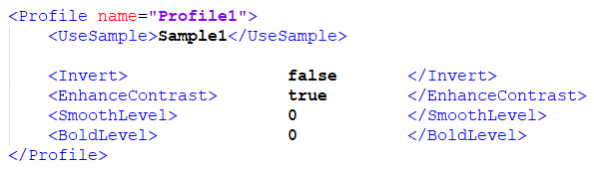

- Invert is used to invert the image color (used when the image has a black background). Its default value is false.
- EnhanceContrast accentuates the contrast of the image. Its default value is true.
- SmoothLevel applies a smooth filter on the image. A higher value means a bigger smooth. Its default value is 0, and having a smooth level greater than 1 is uncommon.
- BoldLevel applies a bold filter on the image. A higher value means a bigger bold. Its default value is 0, and having a bold level greater than 1 is uncommon.
The smooth filter needs to be used when the image has sharp edges that goes directly from black to white (no gray intermediate pixels between). The bold filter needs to be used when the hotspots are too thin.
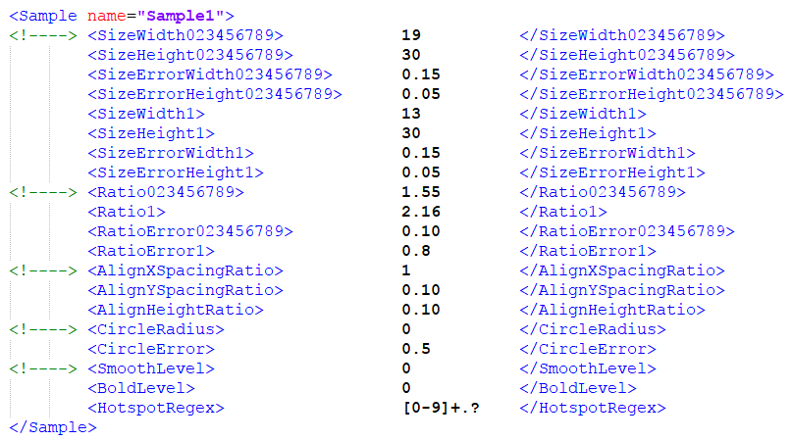
The XML fields for a sample are :

- SizeWidth023456789 indicates the width (in pixels) of all the digits except 1.
- SizeHeight023456789 indicates the height of all the digits except 1.
- SizeWidth1 indicates the width of the digit 1.
- SizeHeight1 indicates the height of the digit 1.
- SizeErrorWidth<…> indicates the accepted error for the width (ratio of the width). Its default value is 0.15 (for both 023456789 and 1).
- SizeErrorHeight<…> indicates the accepted error for the height (ratio of the height). Its default value is 0.05 (for both 023456789 and 1).
To make the size property work, you need to specify the width and the height of both 023456789 and 1 digits, or only one of them if you specified some ratio properties (the missing information can then be calculated).
- Ratio023456789 indicates the ratio height/width of all the digits except 1. Its default value is
1.5833.
- Ratio1 indicates the ratio height/width of the digit 1. Its default value is 2.31.
- RatioError<…> indicates the accepted error for the ratio. Its default value is 0.15 (for both 023456789 and 1).
The ratio property always works since it has default values. If a working size property is defined, the ratio property is no longer used by the application (the size property is more specific).
- AlignXSpacingRatio indicates the maximum horizontal space between two blobs to consider them part of the same word/number. If no size property is defined, it is a ratio of the most left blob width. If the size property is defined, it is a ratio of the SizeWidth023456789 field. Its default value is 1.
- AlignYSpacingRatio indicates the maximum vertical space between the center of two blobs to consider them part of the same word/number. It is a ratio of the most left blob height. Its default value is 0.333.
- AlignHeightRatio indicates the maximum height of the most right blob to consider it part of the same word/number. It is a ratio of the most left blob height. Its default value is 0.333.
The align property always works since it has default values. Modifying it is very rare, the default values work well in most of the cases.
- CircleRadius indicates the radius (in pixel) of the circle around each hotspot.
- CircleError indicates the accepted error for the radius (ratio of the radius). Its default value is 0.50.
- CircleHoughParam2 indicates the second parameter in the Hough Circle Transform algorithm. Its default value is 30.
The circle property only works if the radius is greater than 0.5. If the hotspots don’t have any circle around them, set the radius to 0 or omit the radius field. The houghparam2 is a very underground value that indicates the number of votes needed in the algorithm to accept circles. The default value has been empirically found and works in most of the cases.
- SmoothLevel applies a smooth filter on the hotspot just before Tesseract recognition. A higher value means a bigger smooth. Its default value is 0, and having a smooth level greater than 1 is uncommon.
- BoldLevel applies a bold filter on the hotspot just before Tesseract recognition. A higher value means a bigger bold. Its default value is 0, and having a bold level greater than 1 is uncommon.
- HotspotRegex indicates the regular expression the hotspots need to match. Its default value is [0-9]+.? (a number that can be followed by one letter).
The smooth and bold level in the samples should be often used instead of the ones in the profiles, since it is applied just before Tesseract recognition, preserving the blob properties.

Sampling from the application
It is possible to retrieve samples directly from the application using the Add sample button. Once you click the button, you then need to right click and drag a rectangle around a hotspot :
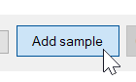
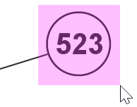

A new profile named Sample is then created, containing one sample. Once the profile is created, using the Add sample button again will add new samples in the profile. You can clear the Sample profile by using the Clear samples button.
The fields used in the profile are the same as the profile that was selected during the sampling process (except for the samples, that are replaced with the one found).
In the retrieved samples, the regular expression and the bold level are used at their default value. Everything else is retrieved directly from the given samples.

Automatic sampling
Automatic sampling is implemented and Its purpose is to let the application find the samples (based on their statistic properties), and will allow to automatically process several images/folders.

- Inputs/shortcuts

- Left click select/unselect a hotspot
- Left click (pressed) and drag select hotspots in the region
- Shift + left click (pressed) and drag select/unselect hotspots in the region
- Right click (pressed) and drag select the region to process, or select a sample
- Wheel scroll scroll vertically
- Shift + wheel scroll scroll horizontally
- Ctrl + wheel scroll zoom in/out
- Wheel button (pressed) and drag free move
- Double wheel button center camera on cursor
- Space launch the OCR recognition (equivalent to the Process button)
- S start sampling (equivalent to the Add sample button)
- H (pressed) hide the hotspots
- Del delete the current hotspot selection
- I invert the current hotspot selection
- Ctrl-Z undo the hotspot selection
- Ctrl-Y redo the hotspot selection

